Academic Year -: 26 – 27 |  | Date: 10/10/2026


SYMBIOSIS INSTITUTE
OF TECHNOLOGY (SIT)
Constituent of SYMBIOSIS INTERNATIONAL (DEEMED UNIVERSITY)
Cyber Security
CA-2 (Part 2) – Case Study Report (Unit 4)
Group Number: Group – 04
Title: “Non-Human Identity and Scoped Delegation for Intrusion Detection and Forensic Attribution of AI-Orchestrated Attacks: A Case Study of the GTG-1002 Espionage Campaign (2025)”
Problem Statement: AI agents now call tools and delegate work to other agents, yet they usually run on broad, long-lived credentials that cannot be traced to an accountable person. The GTG-1002 campaign showed how this gap lets an AI-orchestrated intrusion move fast and stay unattributed. This study analyses the campaign and evaluates whether per-agent identities, scoped delegation and identity-aware logging improve prevention, intrusion detection and forensic attribution.
Name | PRN | CLASS
Raghav Sonchhatra | 23070122172 | CSE-C
Sanidhya Awasthi | 23070122192 | CSE-C
Faheemuddin Sayyed | 23070122196 | CSE-C

Non-Human Identity and Scoped Delegation for Intrusion Detection and Forensic Attribution of AI-Orchestrated Attacks: A Case Study of the GTG-1002 Espionage Campaign (2025)
Raghav Sonchhatra (23070122172), Sanidhya Awasthi (23070122192), Faheemuddin Sayyed (23070122196)
Group 04 · B.Tech CSE-C, Semester VII · Department of Computer Engineering, Symbiosis Institute of Technology, Pune

Abstract
Anthropic identified and thwarted a cyber espionage campaign in mid-September 2025 that it believed was run by a Chinese state-sponsored actor known as GTG-1002 with high confidence. An AI coding agent was used to estimate to 80-90% of the tactical work against around 30 organisations [1]. The operators did not require custom malware: They broke the operation into small chunks for sub-agents, each of which appeared to be a legitimate operation, and linked the agents to normal security tools via the Model Context Protocol. This report looks at the campaign from the defender's perspective. The case of the missing control is identity, since the agents could be given wide authority that was not accountable to anyone. From a public report we reconstruct the campaign, map it to MITRE ATT&CK tactics, and design three controls: a non-human identity (NHI) for each agent, scoped delegation tokens that can only be reduced as they are passed from agent to sub-agent, and an identity-aware intrusion detection layer powered by a hash-chained audit log. A small Python prototype was tested on synthetic workloads over 50 seeded runs, and blocked 77% of misuse calls, reduced exposed production resources from 24.9 to 0 per run, eliminated false alerts (2.34 to 0 per run), and associated every true alert with the human responsible for it, with an additional cost of about 6.4 µs per tool call..
Keywords: Non-human identity; scoped delegation; agentic AI security; intrusion detection; digital forensics; Model Context Protocol; GTG-1002

1. Introduction

AI systems are no longer just answering questions but are now making decisions. Open protocols like Agent2Agent (A2A) [3] and Model Context Protocol (MCP) [2] allow an agent to call tools, retrieve data and pass work to other agents. All of these agents are non-human identities, and identities of this kind already outnumber human identities in enterprise estates, by a factor of approximately 82 to 1, and 42% of all machine identities have privileged or sensitive access [4]. Stolen or compromised credentials continue to be the top initial access point in the 2025 Verizon report, accounting for 22% of the initial access points [5]. Agents are defined rapidly, frequently have the same API key, and can pass tasks to other agents without any documentation of who authorized what.
1.1 Case background: the GTG-1002 campaign

Anthropic's threat intelligence team spotted the activity in mid-September 2025, and released the complete report in November 2025 [1]. The campaign focused on approximately thirty organizations, such as financial institutions, chemical manufacturers and government agencies, as well as large technology firms, and the investigation confirmed a few successful intrusions. The targets were selected by human operators, and they approved a number of escalation steps, including the transition from reconnaissance to exploitation, the use of harvested credentials and the selection of data to be taken. The AI completed the remaining 80-90% of the work, at rates of several operations per second, which no human team could match. To get past the model's safeguards, the operators posed as staff of a legitimate security firm doing defensive testing, and broke the work into small tasks that each looked harmless. The agents pushed commodity open-source tools (network scanners, database exploitation frameworks and password crackers) into custom MCP servers. In some cases, the AI also exaggerated its findings, such as claiming that the credentials were not successful. Anthropic shut down the accounts, informed relevant organizations and authorities, and updated its detection classifiers. It's not a case of ‘vibe hacking' like the one the company reported in the past where humans still handled the majority of work [6] and it's not a case of Google's run-time queries to language models [7] either.
1.2 Relevance to Unit 4

The case touches four Unit 4 topics. Intrusion detection: the campaign was eventually caught because its tempo and multi-stage pattern stood out, and our prototype adds identity-aware IDS rules for agent traffic. Digital forensics: investigators had to reconstruct which agent did what on whose behalf, which is an attribution problem. Security tools: the toolkit was the same class of tools practised in the Kali Linux and Nmap laboratory sessions [8], with the difference that an agent, not a person, was operating them. Malware analysis: because no custom malware was used, signature-based analysis had little to inspect, so detection must rely on behaviour and identity instead.
1.3 Objectives
• Analyse GTG-1002 phase by phase and identify the identity failure that each phase relied on.
• Design controls based on non-human identity and scoped delegation that feed intrusion detection and forensics.
• Build a small prototype and measure prevention, detection, false alerts, attribution and overhead against a shared-key baseline.

2. Literature Review

2.1 AI-orchestrated attacks

Research prototypes showed early that language-model agents can complete offensive tasks. Fang et al. reported agents that exploited test websites without human help [9], and PentestGPT showed that a model can plan and track multi-step penetration tests [10]. Greshake et al. showed that agents reading untrusted content can be steered by indirect prompt injection [11]. OWASP's Top 10 for LLM applications lists excessive agency as a key risk [12], NIST's adversarial machine learning taxonomy covers attacks on and through AI systems [13], and MITRE ATLAS catalogues adversary techniques against AI [14]. Industry threat reports in 2025 then moved from proofs of concept to real operations [1, 6, 7]. Most of this work concentrates on what the model can do or how the provider can refuse; less of it asks how the surrounding environment authorises each action an agent takes.
2.2 Non-human and agent identity

The OWASP Non-Human Identities Top 10 names risks such as improper offboarding, secret leakage, overprivileged identities and identity reuse [15]. The OWASP Top 10 for agentic applications adds agent-specific risks, including identity and privilege abuse and insecure inter-agent communication [16]. Workload identity frameworks such as SPIFFE give each service a verifiable identity [17], in line with the zero-trust principle that no request is trusted because of where it comes from [18]. Chan et al. propose three visibility measures for AI agents: agent identifiers, real-time monitoring and activity logs [19]. South et al. extend OAuth 2.0 and OpenID Connect so that a human can delegate limited, auditable authority to an agent [20].
2.3 Delegation and least privilege
Saltzer and Schroeder's principles of least privilege and complete mediation remain the foundation [21]. Hardy's confused deputy shows what happens when a program uses its own authority for someone else's request [22], which is exactly the position of an agent working on a human's behalf. OAuth 2.0 [23] and token exchange [24] support delegation, with an actor claim that records who acts for whom, and JSON Web Tokens carry such claims [25]. Resource indicators bind a token to one service [26] and are required by the MCP authorization specification [2]. Macaroons showed that a bearer credential can be attenuated, so that each holder can only add restrictions [27]. An IETF draft now proposes an on-behalf-of flow designed for AI agents [28].

2.4 Intrusion detection and digital forensics
Denning's model framed intrusion detection as spotting deviations from normal subject behaviour [29]. Snort [30] and Bro, now Zeek [31], made network IDS practical, and NIST SP 800-94 describes how detection and prevention systems are deployed [32]. Sommer and Paxson warn that anomaly detection struggles with high false-positive rates in real networks [33], a point that matters for agent traffic. The kill chain [34] and MITRE ATT&CK [35] give a shared vocabulary for attack stages. On the forensic side, NIST SP 800-86 [36] and Casey [37] stress the integrity of evidence, and Schneier and Kelsey [38] and Crosby and Wallach [39] show how logs can be made tamper-evident. NIST SP 800-61r3 places incident response inside overall risk management [40].

2.5 Research gap
These strands are mostly studied apart. Identity work rarely measures the effect on detection, and IDS work rarely assumes that each request carries a verifiable delegation chain. As far as we found, no public study evaluates per-agent identity and scoped delegation as inputs to intrusion detection and forensic attribution against a scenario shaped like GTG-1002. This report takes a small step toward closing that gap.

3. Methodology
The study follows four stages. Each stage produces the input for the next, so the controls and the experiment can be traced back to evidence from the real case.
Stage 1: Case reconstruction. We used Anthropic's full report as the primary source [1] and industry reports for context [6, 7]. We extracted the six phases, the human approval gates, the tool categories and the operational tempo. Only public, summary-level information was used, and no part of the attack was reproduced.
Stage 2: Threat and identity-failure mapping. Each phase was mapped to MITRE ATT&CK tactics [35] and to the identity weakness it depended on, using the OWASP NHI and agentic risk lists [15, 16]. For each weakness we chose a control and noted the Unit 4 area it supports. Table 1 shows the result.
Table 1. Mapping of GTG-1002 phases to ATT&CK tactics, identity failures and controls (from [1, 35]).
GTG-1002 phase | ATT&CK tactic | Identity failure | Control in this study | Unit 4 link
1. Initialisation and target selection (security-firm persona) | Resource development | Claimed purpose not bound to an accountable identity | Grant issued by a named human; purpose stored in the token | Forensics
2. Reconnaissance and attack-surface mapping | Discovery | One broad credential across all systems; machine tempo | Resource-prefix scope; R1 tempo; R2 probing | IDS; tools (scanners)
3. Vulnerability discovery and validation | Initial access, execution | Sub-tasks look legitimate in isolation | Per-sub-agent identity; R3 keyed on the whole grant | IDS
4. Credential harvesting and lateral movement | Credential access, lateral movement | Harvested secrets usable by any agent | Scopes that cannot be widened; short lifetimes | IDS; forensics
5. Data collection and extraction | Collection, exfiltration | No limit on blast radius | Resource scoping; refusals logged | Forensics
6. Documentation and handoff | Persistence (access handed on) | Access handed to other teams with no expiry | TTL, depth limit, revocation; hash-chained log | Forensics

Stage 3: Control design. Five principles guided the design. (P1) Every agent has its own identity and a named human owner, so that every action can be traced to a person [15, 19]. (P2) Authority can only narrow along a delegation chain: a sub-agent can never receive more scope, more resources, a longer lifetime or more delegation depth than its parent [20, 24, 27]. (P3) Every tool call passes through one gateway that checks the token, which is complete mediation [21] applied in a zero-trust way [18]. (P4) Every decision, allowed or denied, is written to a hash-chained log [38, 39]. (P5) Detection rules are keyed on the agent identity and the delegation grant rather than on an IP address or a shared key. We preferred these controls to two alternatives. Model-side classifiers are valuable, but an organisation does not control them and attackers can switch models. Network IDS sees mostly encrypted calls to legitimate APIs. Identity is the one signal the defending organisation can enforce and log itself.
Stage 4: Experimental evaluation. We compared two configurations on the same synthetic workload: a baseline in which every agent shares one long-lived API key with wildcard scope, which is common in practice, and the proposed design. Both used identical IDS rules and thresholds, so any difference comes from identity alone. Synthetic data was chosen for ethical and legal reasons, since no real system is touched, and because it gives labelled ground truth and repeatable runs. We ran 50 seeds per configuration. The metrics were: the share of misuse calls blocked; blast radius, meaning distinct production or external resources reached by misuse; false alerts per run; time from the first misuse event to the first true alert; the share of true alerts that name the accountable human; gateway cost per call; and whether the audit log detects tampering. Ground-truth labels were used only for scoring and were never visible to the IDS.

4. Implementation Details
The prototype is written in Python 3 using only the standard library (hmac, hashlib, json, secrets) plus matplotlib for the charts, in about 500 lines. Fig. 1 shows the architecture and Table 2 lists the modules. Tool names are abstract labels and nothing is executed; the prototype only decides whether a call would be allowed, records the decision and analyses the record.
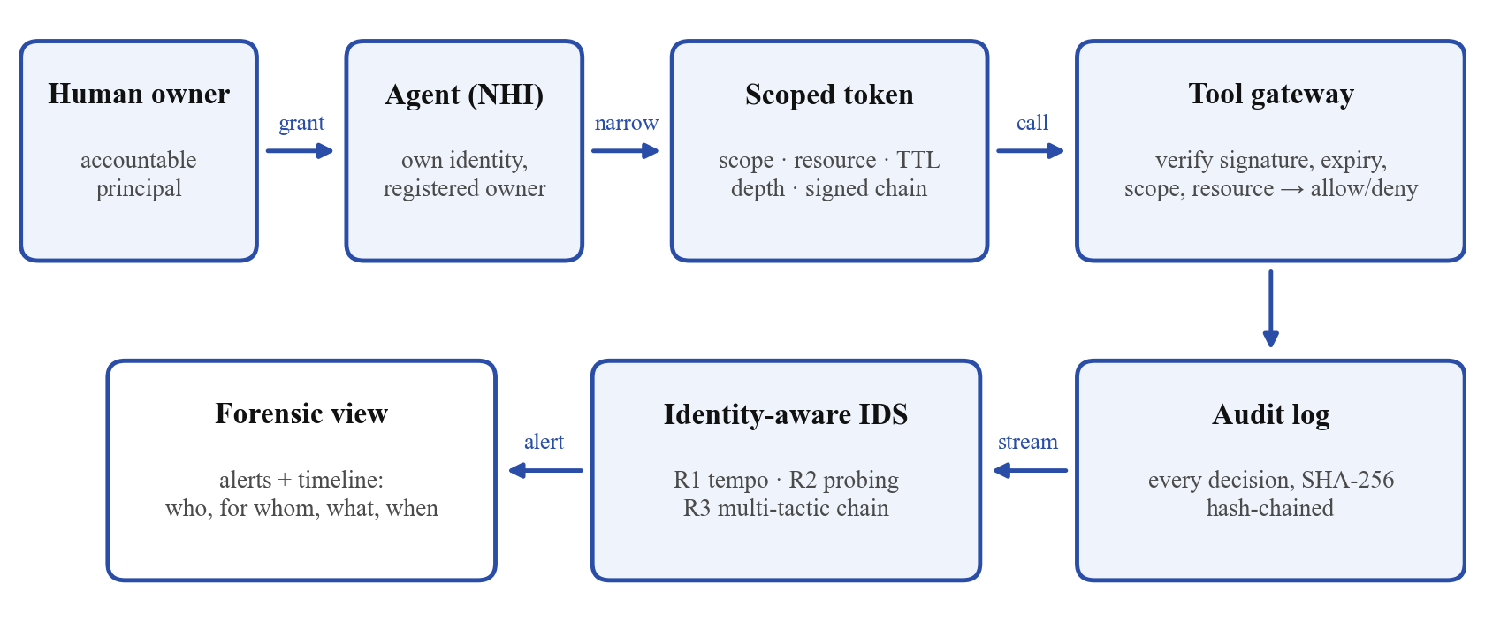
Fig. 1. Architecture of the prototype: identity and delegation (top) and the detection and forensics pipeline (bottom).
Table 2. Prototype modules (implementation/nhi_lab).
Module | Responsibility
identity.py | Identity registry; DelegationAuthority issues, verifies and attenuates HMAC-signed tokens; SharedKeyAuthority for the baseline
gateway.py | Single enforcement point: verify token, check scope and resource, record the decision
audit.py | Append-only SHA-256 hash-chained log with verify() and timeline()
ids.py | Identity-aware rules R1 tempo, R2 probing, R3 multi-tactic chain
workload.py | Synthetic benign agents and the abstract misuse delegation tree
run_experiment.py, make_figures.py | 50-seed comparison, metrics, tamper test, overhead benchmark, charts

Tokens. A token is the Base64 encoding of a JSON claim set followed by an HMAC-SHA256 signature [41]. The claims are the token id, the grant id (shared by the whole delegation tree), the subject agent, the delegation chain starting with the human, the scopes, the resource prefixes, the issue and expiry times, the remaining delegation depth and the declared purpose. The delegate() function rejects any request whose scopes or resources are not a subset of the parent's, issues the child an expiry no later than the parent's, and reduces the depth by one. Refusals are reported as scope_widening, resource_widening or depth_exceeded and are themselves logged.
Gateway and audit log. Each tool maps to one required scope and to the ATT&CK tactic it would serve if misused. The gateway verifies the signature, expiry, revocation, scope and resource prefix, then appends a record containing the time, agent, chain, grant, tool, tactic, resource, decision and reason. Each record also stores the SHA-256 hash of the previous record and its own hash, so editing any earlier record breaks every later link.
Identity-aware IDS. Three simple rules run over the audit stream. R1 (tempo) fires when one agent makes more than 20 calls in 10 seconds, a rate no human operator sustains. R2 (probing) fires when one agent is denied three times within 60 seconds. R3 (multi-tactic chain) fires when one delegation grant touches three or more sensitive tactics within 30 minutes; it is keyed on the grant, so tasks split across sub-agents are correlated again. Each rule and key has a 15-minute cooldown.
Workload. Four benign agents run for three simulated hours: a CI agent with bursty test runs, a documentation agent, an operations agent that inventories hosts and queries a reporting database, and a backup agent that exports production tables to a backup vault. The backup job was included on purpose, because it looks like collection followed by exfiltration. The misuse case follows only the public shape of GTG-1002. An external contractor identity owns an orchestrator holding an engagement grant for inventory and scanning on staging systems only, with a two-hour lifetime and a delegation depth of one. The orchestrator tries to hand five sub-agents wider tasks across discovery, credential access, lateral movement, collection and exfiltration. Phases are separated by human approval gaps of 2-20 minutes, and the tempo varies from 0.3 to 4 calls per second between runs.

5. Results and Discussion
Table 3 summarises the 50-run comparison. Fig. 2 breaks the allowed misuse calls down by tactic, Fig. 3 compares the main outcomes, and Fig. 4 shows the forensic timeline rebuilt from the audit log for one run.
Table 3. Results of the 50-run comparison.
Metric (mean of 50 runs unless stated) | Baseline: shared key | NHI + scoped delegation
Misuse calls attempted per run | 134.3 | 134.3
Misuse calls blocked | 0% | 77.1%
Production/external resources exposed per run | 24.9 | 0
Benign calls wrongly denied (all runs) | 0 | 0
Runs in which misuse was detected | 100% | 100%
Median time to first true alert | 5.3 s | 2.7 s
False alerts per run | 2.34 | 0
True alerts naming the accountable human | 0% | 100%
Misuse audit records attributable | 0% | 100%
Gateway cost per call | 8.3 µs | 14.7 µs

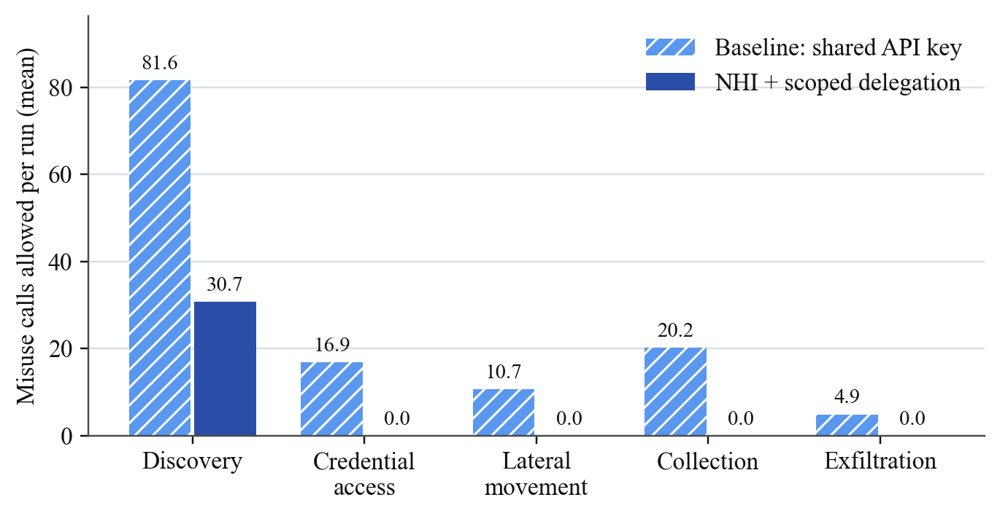
Fig. 2. Mean misuse calls allowed per run, by ATT&CK tactic (50 runs).
Prevention and blast radius. Scoped delegation blocked 77% of misuse calls. Every attempt to hand a sub-agent credential access, remote execution, database export or outbound transfer was refused at delegation time, and the refusal itself became evidence. The calls that still succeeded (about 31 per run) were discovery calls on staging hosts that the engagement had actually authorised. Scoping therefore does not stop misuse of authority that was legitimately granted, so detection is still needed. Production and external resources reached by misuse fell from 24.9 per run to zero, and no benign call was denied in either configuration.
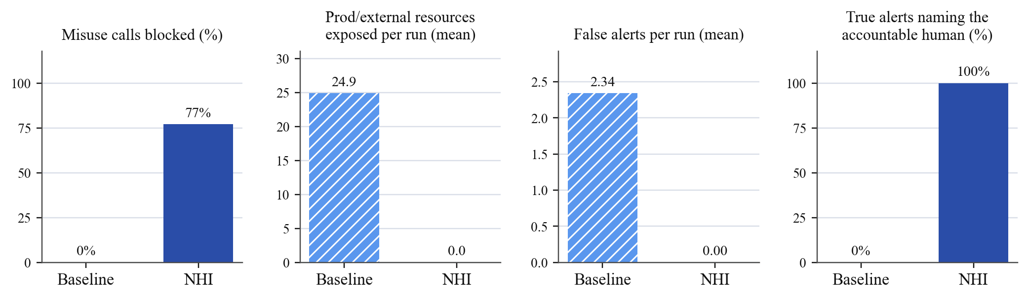
Fig. 3. Main outcomes: misuse blocked, resources exposed, false alerts and attribution (means over 50 runs).
Detection. Both configurations detected the misuse in every run, and the baseline was fast too (median 5.3 s compared with 2.7 s), because high tempo is visible even on a shared key. The difference lies in what an alert means. Baseline alerts name only the shared key, so a responder can contain the attack only by revoking that key and stopping all four legitimate agents along with it. Mixing several agents' traffic on one key also produced 2.34 false alerts per run: the inventory sweeps and the backup job together looked like a multi-tactic chain. With per-agent identities there were no false alerts, and all 8.5 true alerts per run named the agent, its orchestrator and the human owner, so a single grant could be revoked without affecting anything else. The probing rule (R2), which only works when denials are attributed to a specific agent, raised the first alert in most runs.
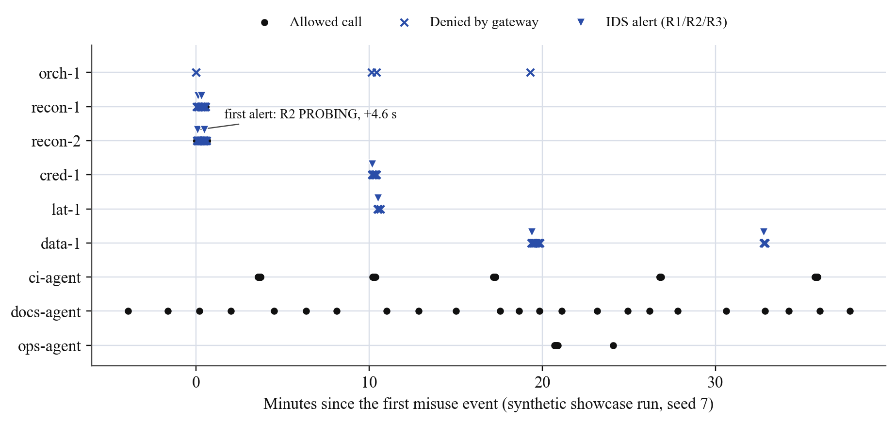
Fig. 4. Forensic timeline rebuilt from the audit log for one run (seed 7): allowed calls, gateway denials and IDS alerts per identity.
Forensics and cost. Every misuse record was attributable to the contractor identity (100% compared with 0%), so the timeline in Fig. 4 can be read directly as "who, on whose behalf, did what, when". In the tamper test, changing one denied record to allowed in a 634-record log was detected at exactly record 100. Verifying a token added about 6.4 µs per call (14.7 µs compared with 8.3 µs for the shared key, in pure Python), which is negligible next to the latency of a model call.
What this means for GTG-1002. In the real campaign the agents ran on the attackers' own infrastructure, so a victim cannot force the attacker to use scoped tokens. The controls therefore apply in three places. AI and tool platforms can require a verified, accountable identity and an explicit, scoped grant before an agent is used for security testing, which turns a role-play claim into a decision that a named person is responsible for. Organisations running their own agents can stop those agents from being hijacked or over-trusted. Target organisations can issue short-lived, narrowly scoped credentials to machines, so that credentials harvested during an intrusion are worth far less. In all three cases the same identity data that limits damage also makes detection more precise and attribution possible.
Limitations. The data is synthetic and the thresholds were set by hand, so the absolute numbers should not be generalised; real deployments would need tuning against real logs, given the known difficulty of anomaly detection [33]. The prototype uses a single signing key and does not cover delegation across organisations, token theft from memory, or an attacker who stays slowly inside a legitimate scope.

6. Conclusion
GTG-1002 showed that an AI agent can carry out most of an intrusion using ordinary tools, with humans stepping in only at a few decision points. The most important lesson for defenders is not about any single exploit; it is that the agents acted with authority that nobody had scoped and nobody could trace. This report mapped each phase of the campaign to the identity failure it relied on and tested three controls: a non-human identity per agent, delegation that can only narrow, and identity-aware detection backed by a tamper-evident log. In our prototype these controls blocked 77% of misuse calls, reduced the exposed production surface to zero, removed false alerts and attributed every alert to an accountable human, at negligible cost. Future work includes testing on real agent logs, learning thresholds per agent, cross-organisation delegation over A2A, and platform-level verification of agent identity before security-sensitive use.

References
[1] Anthropic Threat Intelligence, "Disrupting the first reported AI-orchestrated cyber espionage campaign," Anthropic, San Francisco, CA, USA, Full Report, Nov. 2025. [Online]. Available: https://assets.anthropic.com/m/ec212e6566a0d47/original/Disrupting-the-first-reported-AI-orchestrated-cyber-espionage-campaign.pdf
[2] Model Context Protocol, "Specification, revision 2025-06-18: Authorization," 2025. [Online]. Available: https://modelcontextprotocol.io/specification/2025-06-18/basic/authorization
[3] Google, "Announcing the Agent2Agent protocol (A2A)," Google for Developers Blog, Apr. 2025. [Online]. Available: https://developers.googleblog.com/en/a2a-a-new-era-of-agent-interoperability/
[4] CyberArk, "2025 Identity Security Landscape," CyberArk Software Ltd., Newton, MA, USA, Apr. 2025.
[5] Verizon Business, "2025 Data Breach Investigations Report," Verizon, Apr. 2025.
[6] Anthropic, "Threat intelligence report: August 2025," Anthropic, Aug. 2025. [Online]. Available: https://www-cdn.anthropic.com/b2a76c6f6992465c09a6f2fce282f6c0cea8c200.pdf
[7] Google Threat Intelligence Group, "GTIG AI threat tracker: Advances in threat actor usage of AI tools," Google Cloud, Nov. 2025. [Online]. Available: https://cloud.google.com/blog/topics/threat-intelligence/threat-actor-usage-of-ai-tools
[8] G. F. Lyon, Nmap Network Scanning: The Official Nmap Project Guide to Network Discovery and Security Scanning. Sunnyvale, CA, USA: Insecure.Com LLC, 2009.
[9] R. Fang, R. Bindu, A. Gupta, Q. Zhan, and D. Kang, "LLM agents can autonomously hack websites," arXiv:2402.06664, 2024.
[10] G. Deng et al., "PentestGPT: Evaluating and harnessing large language models for automated penetration testing," in Proc. 33rd USENIX Security Symp., Philadelphia, PA, USA, 2024.
[11] K. Greshake, S. Abdelnabi, S. Mishra, C. Endres, T. Holz, and M. Fritz, "Not what you've signed up for: Compromising real-world LLM-integrated applications with indirect prompt injection," in Proc. 16th ACM Workshop on Artificial Intelligence and Security (AISec), 2023, pp. 79-90.
[12] OWASP GenAI Security Project, "OWASP Top 10 for LLM applications 2025," OWASP Foundation, Nov. 2024. [Online]. Available: https://genai.owasp.org/llm-top-10/
[13] A. Vassilev et al., "Adversarial machine learning: A taxonomy and terminology of attacks and mitigations," National Institute of Standards and Technology, NIST AI 100-2 E2025, Mar. 2025.
[14] MITRE, "ATLAS: Adversarial threat landscape for artificial-intelligence systems." [Online]. Available: https://atlas.mitre.org
[15] OWASP Foundation, "OWASP Top 10 non-human identities risks - 2025," 2025. [Online]. Available: https://owasp.org/www-project-non-human-identities-top-10/2025/top-10-2025/
[16] OWASP GenAI Security Project, "OWASP Top 10 for agentic applications for 2026," OWASP Foundation, Dec. 2025. [Online]. Available: https://genai.owasp.org/resource/owasp-top-10-for-agentic-applications-for-2026/
[17] SPIFFE Project, "Secure Production Identity Framework for Everyone (SPIFFE) overview," Cloud Native Computing Foundation. [Online]. Available: https://spiffe.io/docs/latest/spiffe-about/overview/
[18] S. Rose, O. Borchert, S. Mitchell, and S. Connelly, "Zero trust architecture," National Institute of Standards and Technology, NIST SP 800-207, Aug. 2020.
[19] A. Chan et al., "Visibility into AI agents," in Proc. ACM Conf. Fairness, Accountability, and Transparency (FAccT), Rio de Janeiro, Brazil, 2024.
[20] T. South, S. Marro, T. Hardjono, R. Mahari, C. D. Whitney, D. Greenwood, A. Chan, and A. Pentland, "Authenticated delegation and authorized AI agents," arXiv:2501.09674, Jan. 2025.
[21] J. H. Saltzer and M. D. Schroeder, "The protection of information in computer systems," Proc. IEEE, vol. 63, no. 9, pp. 1278-1308, Sep. 1975.
[22] N. Hardy, "The confused deputy (or why capabilities might have been invented)," ACM SIGOPS Operating Systems Review, vol. 22, no. 4, pp. 36-38, Oct. 1988.
[23] D. Hardt, Ed., "The OAuth 2.0 authorization framework," IETF RFC 6749, Oct. 2012.
[24] M. Jones, A. Nadalin, B. Campbell, J. Bradley, and C. Mortimore, "OAuth 2.0 token exchange," IETF RFC 8693, Jan. 2020.
[25] M. Jones, J. Bradley, and N. Sakimura, "JSON Web Token (JWT)," IETF RFC 7519, May 2015.
[26] B. Campbell, J. Bradley, and H. Tschofenig, "Resource indicators for OAuth 2.0," IETF RFC 8707, Feb. 2020.
[27] A. Birgisson, J. G. Politz, U. Erlingsson, A. Taly, M. Vrable, and M. Lentczner, "Macaroons: Cookies with contextual caveats for decentralized authorization in the cloud," in Proc. Network and Distributed System Security Symp. (NDSS), San Diego, CA, USA, 2014.
[28] T. S. Senarath and A. Dissanayaka, "OAuth 2.0 extension: On-behalf-of user authorization for AI agents," IETF Internet-Draft draft-oauth-ai-agents-on-behalf-of-user-02, Aug. 2025.
[29] D. E. Denning, "An intrusion-detection model," IEEE Trans. Software Engineering, vol. SE-13, no. 2, pp. 222-232, Feb. 1987.
[30] M. Roesch, "Snort: Lightweight intrusion detection for networks," in Proc. 13th USENIX Systems Administration Conf. (LISA), Seattle, WA, USA, 1999, pp. 229-238.
[31] V. Paxson, "Bro: A system for detecting network intruders in real-time," Computer Networks, vol. 31, no. 23-24, pp. 2435-2463, Dec. 1999.
[32] K. Scarfone and P. Mell, "Guide to intrusion detection and prevention systems (IDPS)," National Institute of Standards and Technology, NIST SP 800-94, Feb. 2007.
[33] R. Sommer and V. Paxson, "Outside the closed world: On using machine learning for network intrusion detection," in Proc. IEEE Symp. Security and Privacy, Oakland, CA, USA, 2010, pp. 305-316.
[34] E. M. Hutchins, M. J. Cloppert, and R. M. Amin, "Intelligence-driven computer network defense informed by analysis of adversary campaigns and intrusion kill chains," in Proc. 6th Int. Conf. Information Warfare and Security (ICIW), 2011, pp. 113-125.
[35] B. E. Strom, A. Applebaum, D. P. Miller, K. C. Nickels, A. G. Pennington, and C. B. Thomas, "MITRE ATT&CK: Design and philosophy," The MITRE Corporation, McLean, VA, USA, Tech. Rep. MTR180360, 2018.
[36] K. Kent, S. Chevalier, T. Grance, and H. Dang, "Guide to integrating forensic techniques into incident response," National Institute of Standards and Technology, NIST SP 800-86, Aug. 2006.
[37] E. Casey, Digital Evidence and Computer Crime: Forensic Science, Computers, and the Internet, 3rd ed. Waltham, MA, USA: Academic Press, 2011.
[38] B. Schneier and J. Kelsey, "Secure audit logs to support computer forensics," ACM Trans. Information and System Security, vol. 2, no. 2, pp. 159-176, May 1999.
[39] S. A. Crosby and D. S. Wallach, "Efficient data structures for tamper-evident logging," in Proc. 18th USENIX Security Symp., Montreal, QC, Canada, 2009, pp. 317-334.
[40] A. Nelson, S. Rekhi, M. Souppaya, and K. Scarfone, "Incident response recommendations and considerations for cybersecurity risk management: A CSF 2.0 community profile," National Institute of Standards and Technology, NIST SP 800-61r3, Apr. 2025.
[41] H. Krawczyk, M. Bellare, and R. Canetti, "HMAC: Keyed-hashing for message authentication," IETF RFC 2104, Feb. 1997.

